**Abstract:**

The quality of the air we breathe is a fundamental determinant of public health and environmental well-being. With the accelerating pace of urbanization and industrial growth, the assessment and management of air quality have emerged as critical global concerns. This project presents the development of a robust and comprehensive Air Quality Index (AQI) monitoring system tailored to analyze data spanning the years 2020-2023 across diverse cities in each state of India.

Utilizing an array of environmental sensors and sophisticated data analytics, this system aims to amalgamate and process extensive air quality datasets. The core focus lies in establishing a web-based interface that empowers users to visualize, interpret, and derive meaningful insights from this plethora of information effectively.

The project draws upon the compilation of multi-year air quality data, integrating parameters such as particulate matter (PM2.5 and PM10), nitrogen dioxide (NO2), sulfur dioxide (SO2), carbon monoxide (CO), and ozone (O3) levels. These data sets, acquired from various monitoring stations across cities in India, enable comprehensive spatial and temporal analyses.

The web-based interface developed as part of this project provides intuitive visualization tools and interactive features. Users gain access to dynamic graphs, heat maps, trend analyses, and comparative studies across different time frames and geographical locations. Moreover, the system incorporates machine learning algorithms to forecast air quality trends and potential risk assessments.

**Objective:**

The primary objective of this project is to create a user-friendly platform that utilizes historical air quality data to calculate and present the Air Quality Index for different cities in India. The system aims to provide valuable insights into the variations and trends in air quality over the years and across different regions.

Utilize comprehensive datasets spanning the years 2020-2023 to facilitate the analysis of variations and trends in air quality parameters, including particulate matter (PM2.5 and PM10), nitrogen dioxide (NO2), sulfur dioxide (SO2), carbon monoxide (CO), and ozone (O3) levels.

Enable users to access and interpret AQI trends and variations across different regions and timeframes through intuitive visualizations and interactive tools within the platform. Implement robust data analytics techniques, including machine learning algorithms, to forecast air quality trends and provide predictive insights for potential risk assessment.

**Problem Statement:**

Considering the importance of air to human existence, air pollution is a critical issue that requires collective effort for prevention and control. Different types of anthropogenic activities have resulted in environmental dilapidation and ruin. One of the tools that can be used for such a campaign is Air Quality Index (AQI). The AQI was based on the concentrations of different pollutants: There is a need for constant and continuous environmental monitoring of air quality for the development of AQI, which in turn will enable clear communication of how clean or unhealthy the air in the study area is.

**Modules & Description:**

Considering the importance of air quality to human existence, the project encompasses the following modules:

1. **Data Collection Module:** Gathers air quality data from the years 2020-2023 for various cities in each state of India.
2. **Data Processing Module**: Utilizes Python (pandas, NumPy) to process and clean the dataset, preparing it for analysis.
3. **Analysis Module**: Employs statistical and machine learning techniques (TensorFlow) to calculate the Air Quality Index based on pollutant concentrations.
4. **Visualization Module:** Uses JSP, HTML, CSS, and Python (Plotly, mat plot) to create interactive and informative visualizations of air quality data.
5. **User Interface Module:** Provides a web-based interface for users to interact with and explore air quality information for different cities and states.

**Functionalities:**

The system analyzes air quality based on the dataset from 2015-2020, providing the following functionalities:

1. Data Collection: Gather and compile air quality data from various sources and monitoring stations, including pollutant concentrations (PM2.5, PM10, NO2, SO2, CO, O3), meteorological data, and geographical information.
2. Data Processing and Cleaning: Utilize tools like Python (Pandas, NumPy) to clean, preprocess, and organize raw data for analysis, handling missing values, outliers, and formatting issues.
3. AQI Calculation: Employ statistical methods or machine learning algorithms to calculate the AQI based on pollutant concentrations, converting individual pollutant readings into a single, standardized index for easier interpretation.
4. Trend Analysis: Analyze historical data to identify patterns, trends, and fluctuations in air quality over time and across different regions. This includes temporal trends (daily, monthly, yearly) and spatial variations among various monitoring locations.
5. Visualization: Utilize data visualization tools (Plotly, Matplotlib) to create interactive and informative visual representations such as graphs, heatmaps, maps, and trend charts, aiding in the interpretation and communication of air quality data.
6. Prediction and Forecasting: Employ predictive modeling techniques (e.g., XGBoost, Random Forest) to forecast future air quality trends based on historical data, enabling proactive decision-making and risk assessment.
7. Geospatial Analysis: Conduct spatial analysis to understand the distribution of air pollutants across different geographical regions and cities, identifying hotspots and areas requiring targeted interventions.
8. User Interface: Develop a user-friendly web-based interface allowing users to access, explore, and interact with AQI data, providing functionalities for data querying, filtering, comparisons between cities, and time-based analyses.
9. Alerts and Notifications: Implement a system to generate alerts or notifications based on predefined thresholds or significant changes in air quality, facilitating timely actions and public awareness.

**Tools Used:**

1. **Backend:**

Python serves as the backend programming language, leveraging libraries like Pandas for efficient data manipulation and analysis, NumPy for numerical computations, and TensorFlow for implementing machine learning algorithms. Pandas’ aids in handling and processing large datasets, NumPy facilitates complex mathematical operations, and TensorFlow supports the creation of models for AQI calculation based on pollutant concentrations.

1. **Web Development:**

Java Server Pages (JSP), HTML, and CSS collectively form the foundation for web development. JSP allows for dynamic content generation within web pages, enabling integration with backend functionalities for retrieving and presenting air quality data. HTML defines the structure of web pages, while CSS styles these pages, ensuring a visually appealing and user-friendly interface for displaying AQI information.

1. **Data Visualization**:

Plotly and Matplotlib are Python libraries used for data visualization. Plotly offers interactive and customizable graphs and charts, providing a rich visual representation of air quality metrics such as pollutant concentrations and AQI trends. Matplotlib complements this by offering a wide range of static plotting options, allowing for detailed and precise visualizations of air quality data.

1. **Dataset Handling**:

CSV (Comma-Separated Values) is a widely used file format for storing tabular data, including air quality datasets. The system employs CSV for efficient storage, retrieval, and handling of the collected air quality data. This format ensures compatibility and ease of use in various stages of data processing, including input, manipulation, and output for analysis and visualization.

1. **User Interface Design**:

SCarbon is a design system that aids in creating user interfaces with a focus on consistency, accessibility, and user experience. It provides a set of guidelines, components, and styles to ensure a cohesive and intuitive user interface design. SCarbon assists in structuring the web-based interface, offering a visually appealing layout and interaction elements for users to navigate and interact seamlessly with the air quality information presented on the platform.

**Analysis Flow Diagram:**

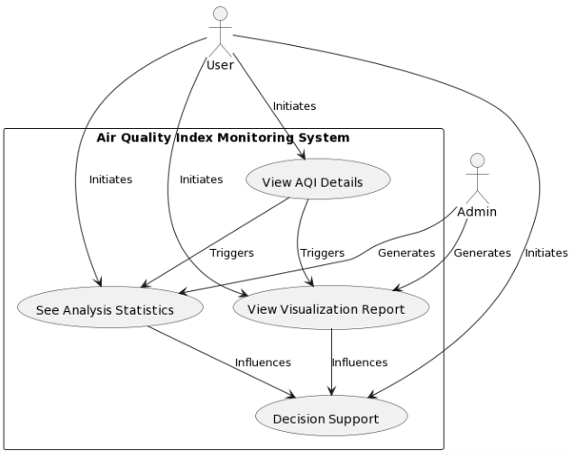

**Output:**

Main Page:

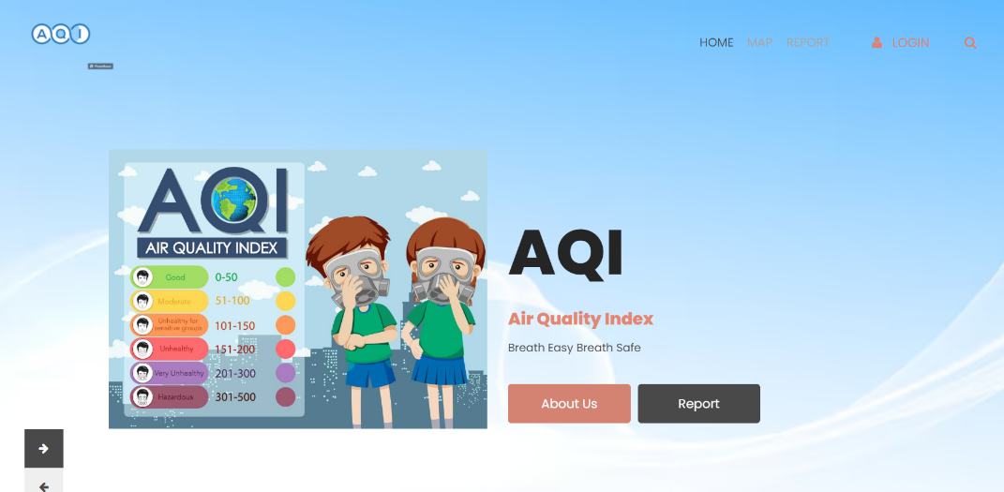

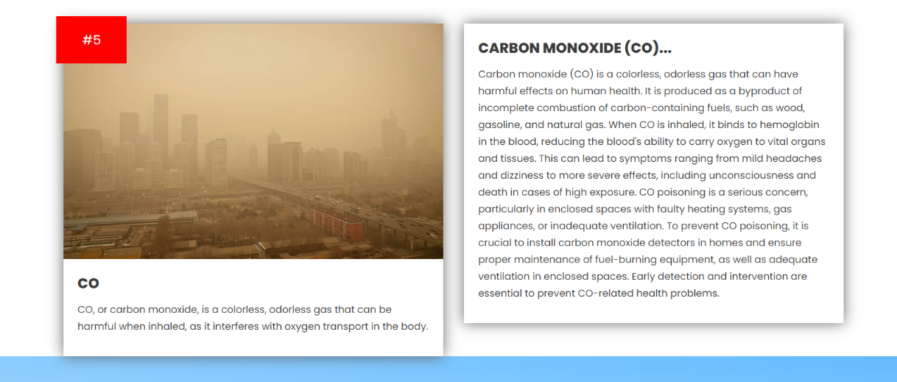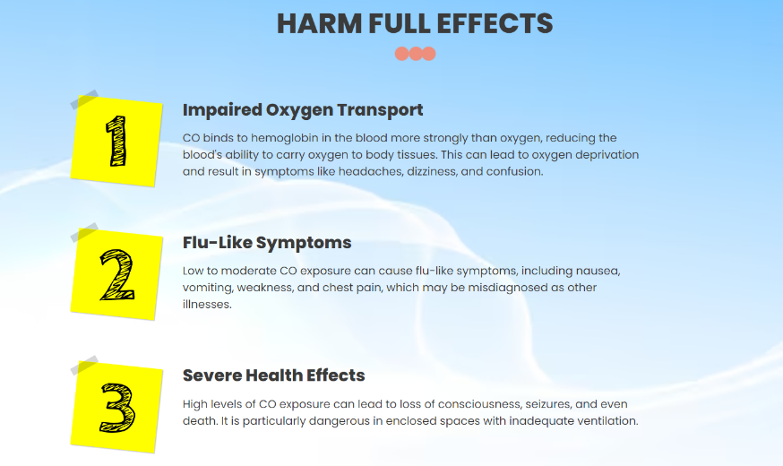

**Analysis of Model:**

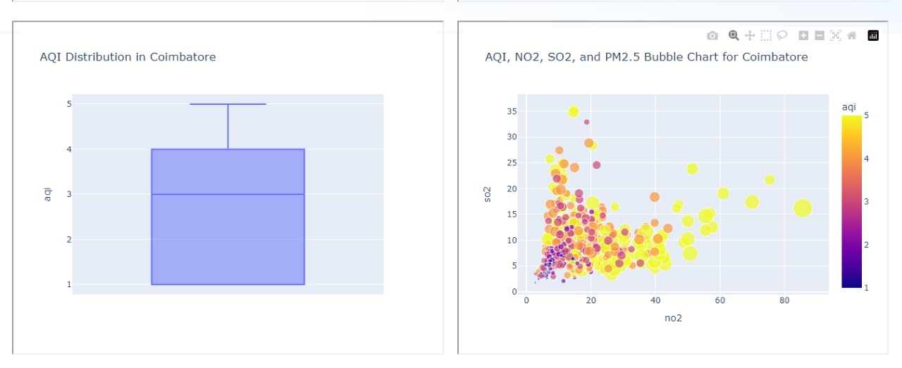

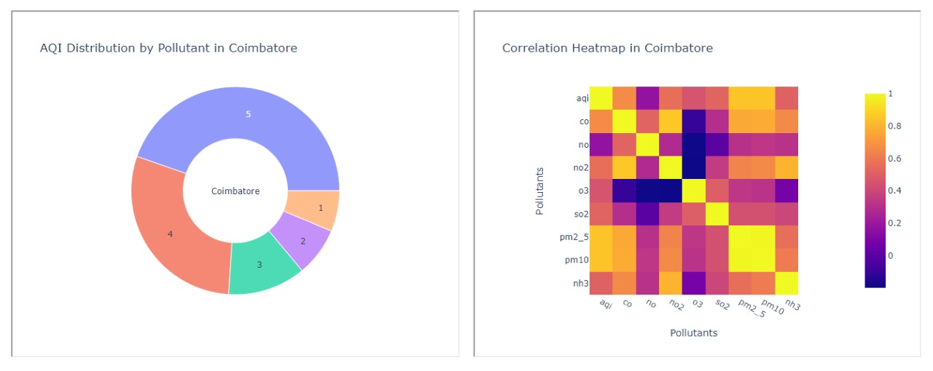

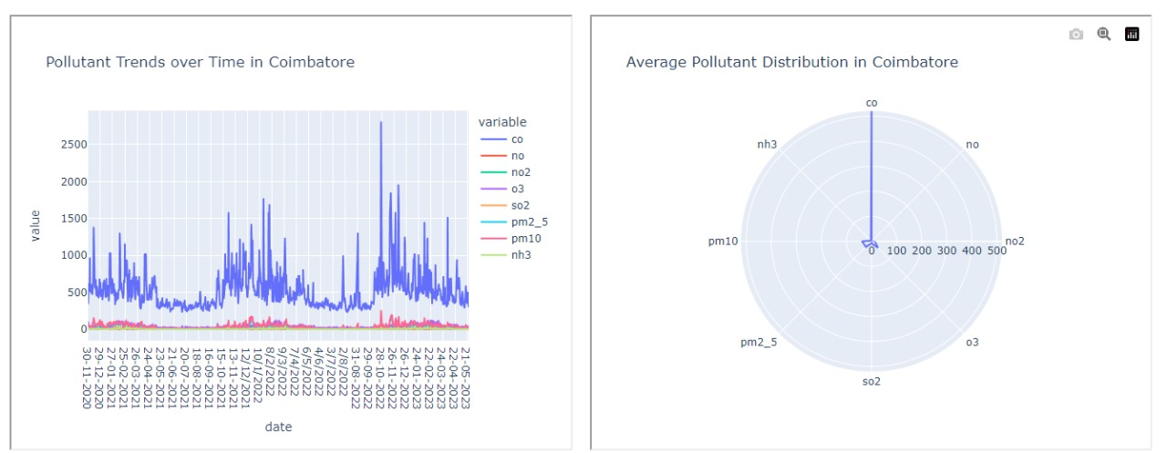

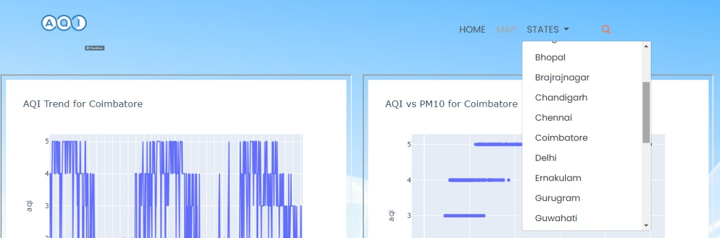

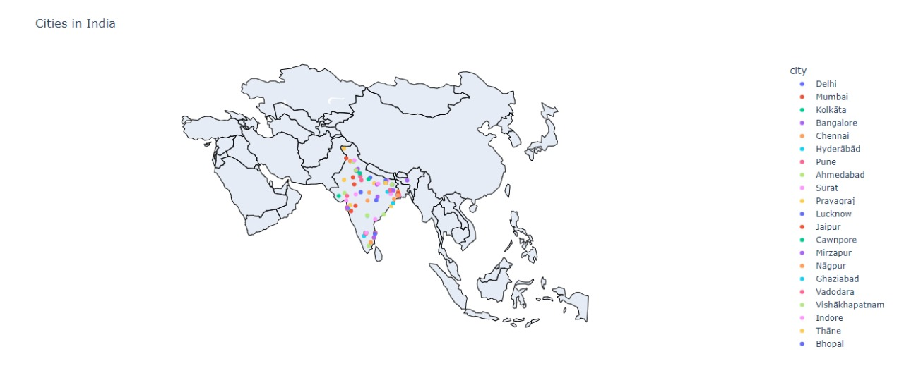

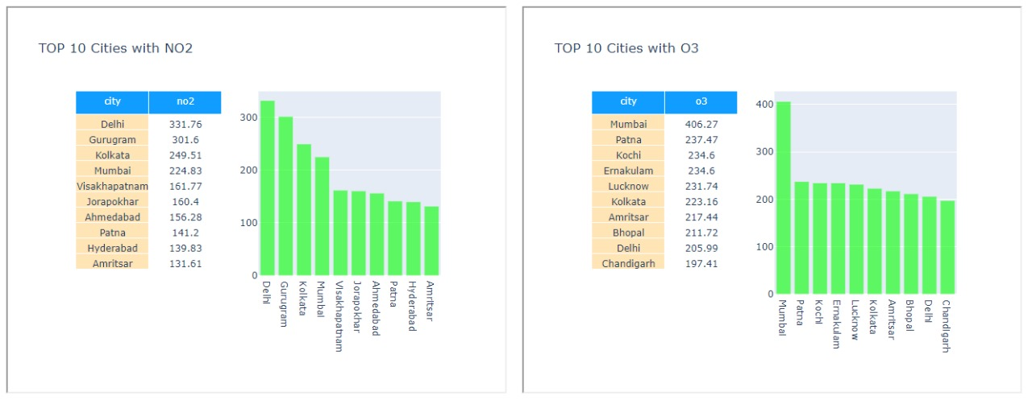

**Prediction Model for AQI range:**

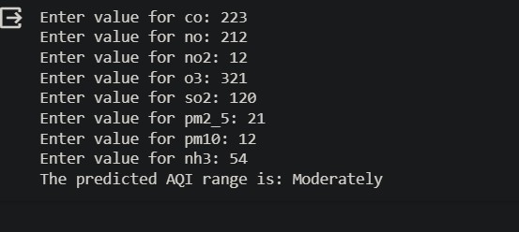

**Classification Model for AQI Range:**

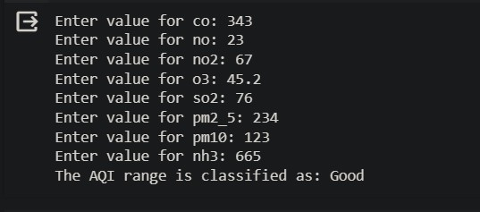

**Conclusion:**

The development of the Air Quality Index monitoring system is crucial for addressing the growing concerns of air pollution. This project aims to provide a comprehensive tool for continuous monitoring and analysis of air quality data, facilitating informed decision-making and promoting awareness about the importance of air quality in our daily lives.

The integration of various technologies and tools ensures a robust and user-friendly system that contributes to environmental conservation efforts. The culmination of this project in developing an Air Quality Index (AQI) monitoring system for the Indian dataset from 2020 to 2023 underscores its significance in combating escalating air pollution concerns. By employing Java Server Pages (JSP) as the primary tool for web presentation, this system offers an accessible interface to comprehend and analyze crucial air quality metrics.

Utilizing advanced prediction models such as the XGBRegressor for regression and Random Forest for classification, this system transcends mere data analysis. It facilitates predictive capabilities, allowing stakeholders to anticipate future air quality trends, thus aiding in proactive decision-making and policy formulation.

Through the integration of various technologies like Plotly and Matplotlib for data visualization, the system empowers users with meaningful insights into air quality variations and trends. These visualizations not only enhance comprehension but also serve as catalysts for raising public awareness regarding the profound impact of air quality on daily life and overall health.

By amalgamating these tools and methodologies, this comprehensive system acts as a pivotal tool for continuous monitoring and analysis. It promotes informed decision-making among policymakers, environmental agencies, researchers, and the public, fostering a collective effort towards environmental conservation and sustainable living practices.

In conclusion, this project culminates in a robust, user-friendly AQI monitoring system adept at leveraging predictive analytics and advanced classification techniques to provide actionable insights. It serves as an indispensable tool in combating air pollution, encouraging awareness, and steering efforts towards ensuring cleaner air and a healthier environment for all.